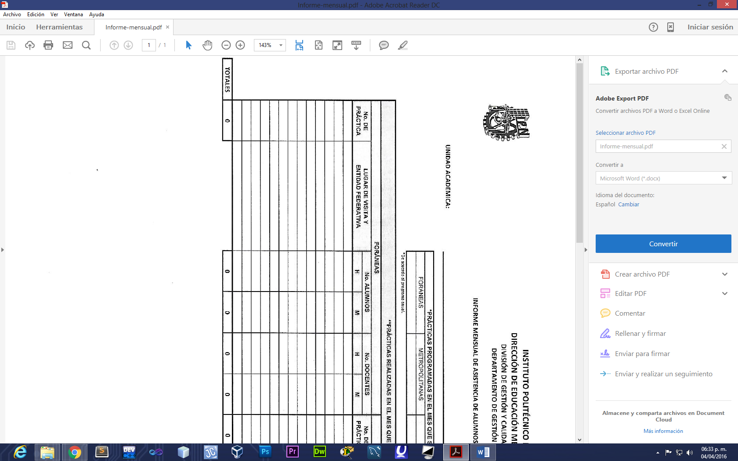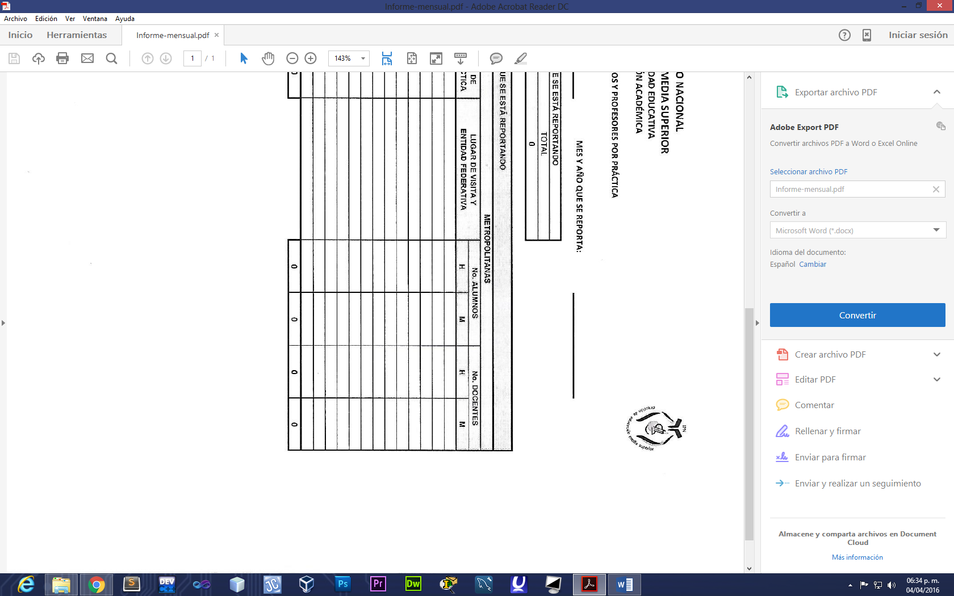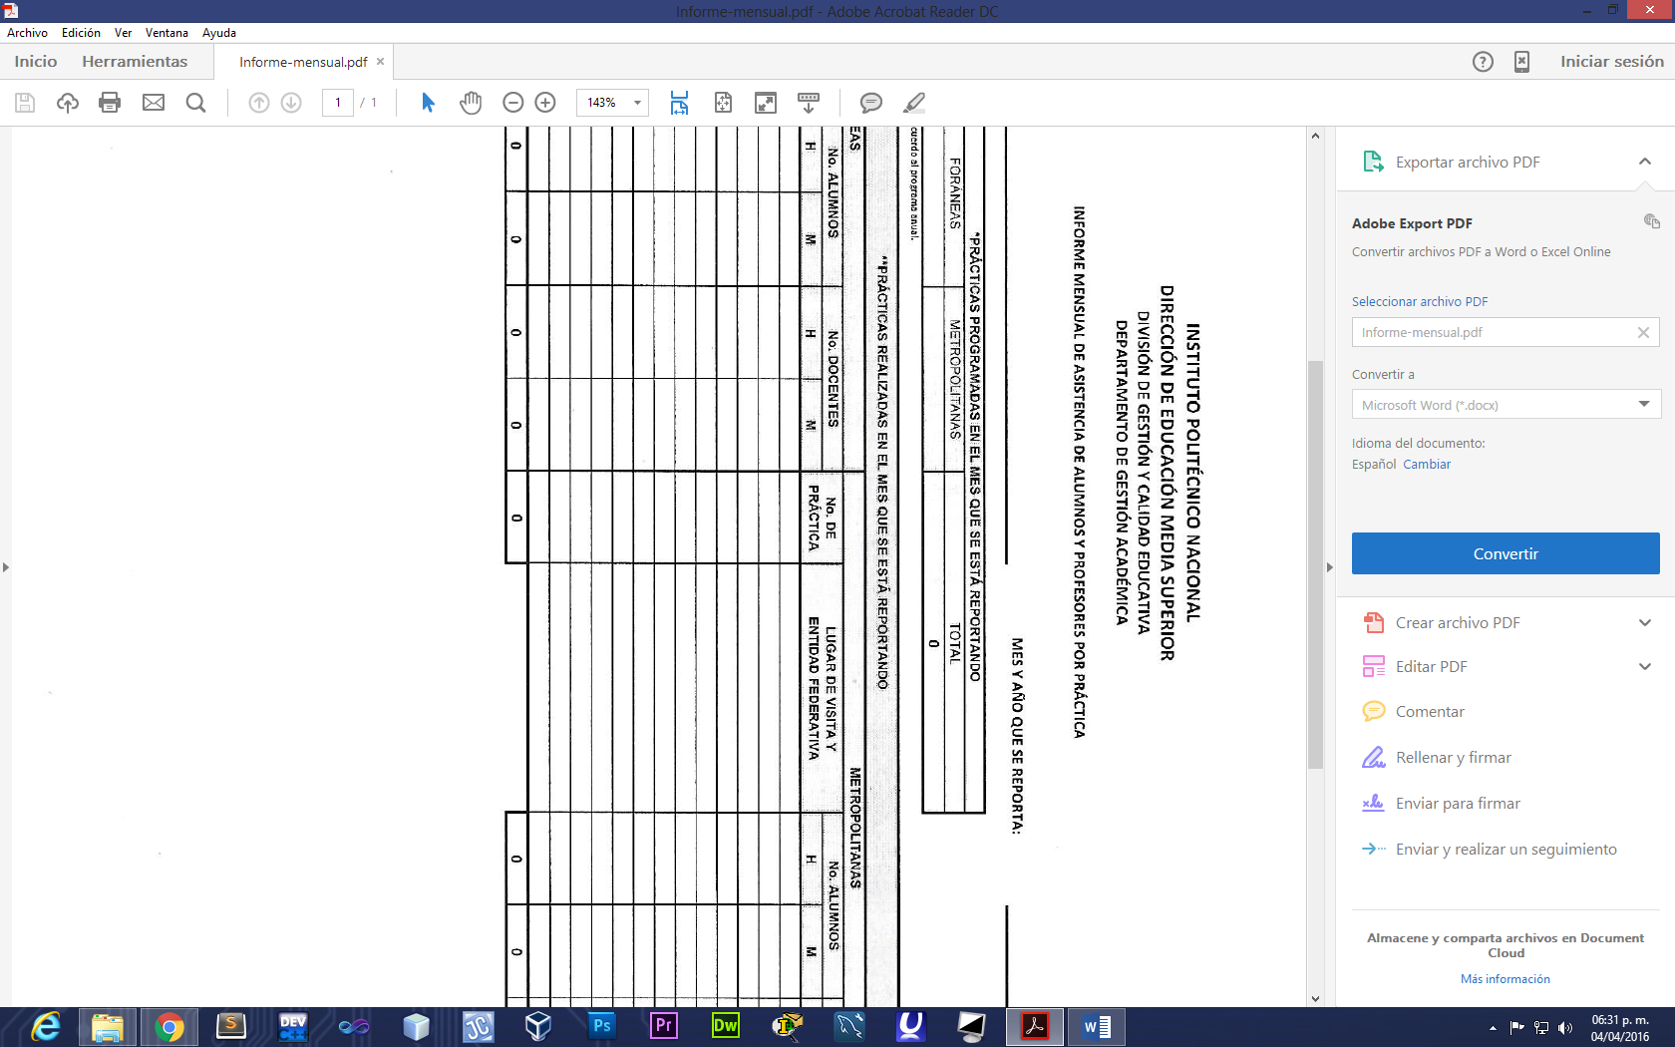

MES Y AÑO EN QUE SE REPORTA:  /

UNIDAD ACADEMICA: CECYT NO. 8 “NARCISO BASSOLS”

|  |  |  |
| --- | --- | --- |
| *PRACTICAS PROGRAMADAS EN EL MES QUE SE ESTA REPORTANDO | | |
| FORANEAS | METROPOLITANAS | TOTAL |
|  |  |  |

*de acuerdo al programa anual

|  |  |  |  |  |  |  |  |  |  |  |  |  |
| --- | --- | --- | --- | --- | --- | --- | --- | --- | --- | --- | --- | --- |
|  | *PRACTICAS PROGRAMADAS EN EL MES QUE SE ESTA REPORTANDO | | | | | | | | | | | |
| FORÁNEAS | | | | | | METROPOLITANAS | | | | | |
| No. DE PRACTICA | LUGAR DE VISITA Y ENTIDAD FEDERATIVA | No. ALUMNOS | | No. DOCENTES | | No. DE PRACTICA | LUGAR DE VISITA Y ENTIDAD FEDERATIVA | No. ALUMNOS | | No. DOCENTES | |
| H | M | H | M | H | M | H | M |
|  | / |  |  |  |  |  | / |  |  |  |  |
|  | / |  |  |  |  |  | / |  |  |  |  |
|  | / |  |  |  |  |  | / |  |  |  |  |
|  | / |  |  |  |  |  | / |  |  |  |  |
|  | / |  |  |  |  |  | / |  |  |  |  |
|  | / |  |  |  |  |  | / |  |  |  |  |
|  | / |  |  |  |  |  | / |  |  |  |  |
|  | / |  |  |  |  |  | / |  |  |  |  |
|  | / |  |  |  |  |  | / |  |  |  |  |
|  | / |  |  |  |  |  | / |  |  |  |  |
|  | / |  |  |  |  |  | / |  |  |  |  |
|  | / |  |  |  |  |  | / |  |  |  |  |
|  | / |  |  |  |  |  | / |  |  |  |  |
| TOTALES |  |  |  |  |  |  |  |  |  |  |  |  |